1)a) Label the pictures with the expressions from the box
Land pollution / water pollution / land pollution / noise
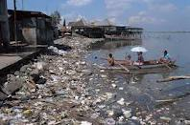
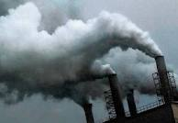
TYPES OF POLLUTION

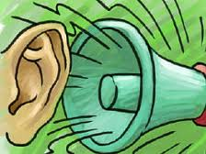
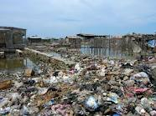

b) What are the effects of pollution on the environment and on the people?
Look at the labeled pictures and complete the table:
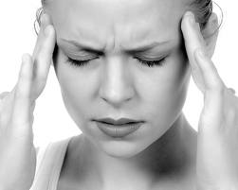 | 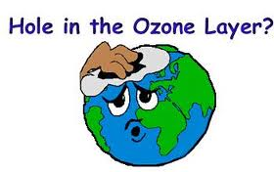 | 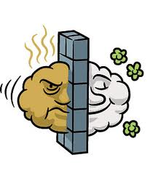 | 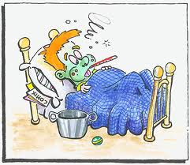 | 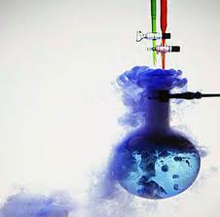 | 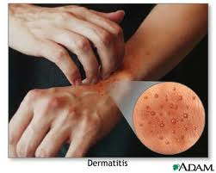
headache | Hole in the ozone layer | smog | Disease / sickness | Chemical reaction | Skin rash
 | 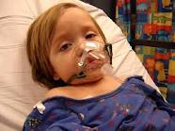 | 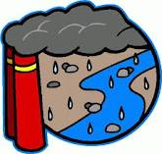 | 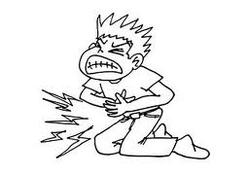 |  | 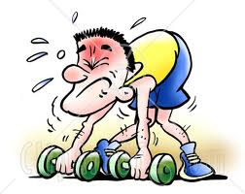
burn | Breathing problem | Acid rain | stomachache | deafness | weakness

Effects of pollution on people | Effects of pollution on the environment

2)a) Now, with your partner read text1 and text 2 and find out the causes and the effects of each type of pollution
TEXT 1 TEXT 2
Living in noisy overcrowded towns has become dangerous because everyday exposure to noise can cause headache, earaches and may lead to deafness.
Because factories release fumes, the air people breathe gets polluted. Other well-known effects of fumes are smog, acid rain and holes in the ozone layer.

Text | Type of pollution | causes | effects
1 |  |  | -  -  -  -
2 |  |  | -  -  -
b) Then, answer the question:
Why is the air we breathe polluted? (text 1)
The air we breathe is polluted ……………………………………………………………………………………………………

3)Read text 3 and text 4 and answer the questions:
TEXT 3 TEXT 4
Paints, solvents, glues are all inflammable.
They can catch fire and result in burns, skin rashes or risky chemical reactions.
Toxic substances found in the food we eat and the air we breathe accumulate in our bodies and result in poor health like weakness, pains, aches disease and sickness.

a)Find equivalent expressions from text 3:
Contaminated food = ……………………………………………………………………………………………………………………………………………..
Polluted air = ………………………………………………………………………………………………………………………………………………………….

b) Are contaminated food and polluted air harmful of our health? Justify. …………………………………………………………………………………………………………………………………………………………………………………
c) Read text 4 and label the pictures:
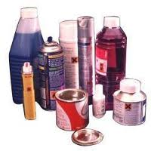
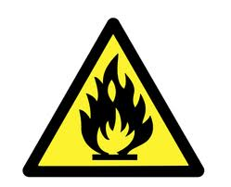

…………………………………..
…………………………………………………….

c)What can happen when inflammables catch fire?
…………………………………………………………………………………………………………………………………………………………………………………
d)Connect the sentence parts with a linker of consequence:
They can be harmful for the environment and people’s health.
-
-
-
-

Inflammables can catch fire.

4)Circle the correct alternative:
Pollution is dangerous. (That’s why / Because / But) everyone has to take actions against it. For example:
(Therefore / whereas / because) household chemicals are harmful, we must handle them with care.
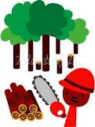
Batteries from toys, mobile phones and cars leak heavy metals. (Because / So / Can) they must be disposed of properly.
Moreover, people cut trees. (As a result / First / Because) many bird species disappear.
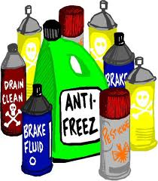
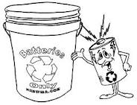
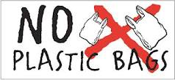
Besides, plastic bags are a major source of waste. (Therefore / Because / will) we should not throw them everywhere.

